**Testing documentation**

|  |  |  |  |  |  |
| --- | --- | --- | --- | --- | --- |
| **Test Number** | **Purpose of test** | **Variables or data tested** | **Expected outcome** | **Actual outcome** | **Action taken** |
| 1 | Ensuring that all of the modules are imported. | Import:  Sys, pygame, random, time, from pygame.locals import *. | Successful program run with no import errors. | Successful program run with no import errors. | None needed. |
| 2 | Wall collision checking. Moving the centipede to other side of the screen upon collision. | If statements,  snakeHeadX, snakeHeadY. | Centipede moves into a wall and when the collision is detected will move to the opposite wall giving the appearance of moving through the wall. | The centipede moves as expected and moves through one segment at a time. | None needed. |
| 3 | Check that the randomly generated food generates after 1 or less frame. | random module, if statements,  randrange,  snakeFood, snakeFoodX, snakeFoodY,  snakeHeadX,  snakeHeadY. | When the food disappears and new piece of food should appear in a random location at the same time or 1 frame after. | The food appears at the same time another is picked up. (Tested at 1 FPS to ensure accuracy). | None needed. |
| 4 | Checking that the collision with snakeFood will create a sound. | If statements,  eatingFood, snakeFood, snakeFoodX, snakeFoodY,  snakeHeadX,  snakeHeadY. | Makes the sound when collision is detected. | Makes the sound when collision is detected. | None needed. |
| 5 | Increasing speed when centipede eats food. | If statements, grid, snakeHeadX, snakeHeadY. | Speed will increase by different amounts depending on what is eaten and will increase in speed gradually. | Speed increases with each piece of food collected and will increase by a different amount for different type of food. (Tested by multiplying the variable grid (which determines speed) by 10). | None needed. |
| 6 | Checking that score increases and decreases when applicable. | If statements, score, snakeCrash, lifeLost snakeHeadX. snakeHeadY, snakeFoodX,  snakeFoodY,  bonusCheeseX, bonusCheeseY. | The score should increase when food is eaten and decrease when a life is lost. | The score increases when food is eaten and decreases when a life is lost. | None needed. |
| 7 | Check if when lives are all gone the game over screen will show. | If statements, gameOver, lives, lifeLost. | When the lives variable is equal to 0 the game over screen will show. | The amount of lives shown is equal to 0 and the game over menu appears. | None needed. |
| 8 | Check to see if the lives variable increases by 1 when the heart is collected. | If statements, lives, lifeGained, snakeHeadX, snakeHeadY, extraLifeX, extraLifeY. | When the heart is collided with, the lives variable will increase by 1. | Lives was equal to 4 (1 more than originally) when the heart was collected and was tested in the python shell. | None needed. |
| 9 | Check if key presses work in the game over menu. | gameOver, while loop, gameRun, quit, main_loop(). | In the game over menu the game menu should start when the “space” button is pressed and the game should quit when the “q” key is pressed. | When “q” is pressed the game exits and when the “space” key is pressed the main loop will start over and the menu will open. | None needed. |
| 10 | Test for the border highlighting buttons in the main menu when arrow keys are pressed | playSelected,  exitSelected,  helpSelected,  gameMenu | The border should print onto the screen as an image then the image for the button should print over it showing both the border and the button. | The border is visible as are the buttons but they are not aligned correctly. | Change the values of the X and Y position for the border. |
| 11 | Test if the help menu works and closes when the space bar is pressed. | helpSelected, helpMenuOpen | Help menu should display and return to the main menu when the space bar is pressed. | The help menu displays and there is a short delay when pressing the space bar when returning. | No action required as the delay stops the user from pressing the button twice. |
| 12 | Do the arrow keys move the centipede in the corresponding direction? | snakeHeadX, snakeHeadY. | The centipede should move up, down, left or right when the user presses one of the buttons. | The centipede moves in the correct direction depending on the button pressed. | None needed. |
| 13 | Does the play button start the game correctly? | gameRun, playSelected, gameMenu. | The play button should start the game and change gameMenu to false so it closes | The menu closes and the game will run as normal. | None needed. |
| 14 | Can the score be shown at the end of the game on the game over screen? | score, gameOver, msg, gameRun. | The score should be displayed in a message once the amount of lives is equal to 0. | The score is displayed in the game over menu and stays until the user selects an option. | None needed. |
| 15 | Do the messages show when calling the msg function? | msg. | The messages should all show in the part of the game they are called. | The score, lives, help text and game over text all show when calling the msg function. | None needed. |
| 16 | All defined variables are used and are work. | All variables. | All should work and be used at least once. | All variables are shown multiple times whether they are changed or not. | None needed. |
| 17 | Is the snake function in working order and does it work when called? | snake, XandY, snakehead, extlist, grid. | The snake function should be called and run when the game starts and when the player collects food. | The snake function works when called and extends one segment at a time when food is collected. | None needed. |
| 18 | Does the bonus cheese appear and does it function correctly? | bonusCheeseX, bonusCheeseY, amountOfExt, bonusCheese, snakeHeadX, snakeHeadY, grid. | The bonus cheese should appear when the amountOfExt is between 30 and 35. Upon collecting it the score should increase by 50, speed increase by 0.3, the extensions increase by 3 and the bonus point should disappear off the screen | The bonus cheese does appear on the screen when the amount of extensions is between 30 and 35. It also increases the other variables like expected. | None needed. |
| 19 | Does the caption show in the top of the window? | caption. | The caption will show in the top of the window. | The caption is visible in the top of the window | None needed. |
| 20 | Is the speed of the centipede reasonable? | grid, snakeHeadX, snakeHeadY | The snake should be a reasonable speed. | The speed of the snake is not in accordance of the specification. It was first at 10px per frame but the specification states 4px per frame. | I have changed the variable grid from 10, to 4 so it will meet the specification |
| 21 | Does the centipede speed up as time progresses? | grid. | The game should speed up in some way as it progresses. | As time progresses the game does speed up but not evenly over time. Instead it speeds up when food is collected. | The speed of the centipede still increases over time just not evenly so no action is required. |
| 22 | Checking if segments stack when the centipede eats food | amountOfExt, extlist, snakeCrash, lives, lifeLost. | Sengments should stack and follow the centipede head in exactly the same route as the centipede head. | All of the segments followed the centipede head as expected | None needed. |
| 23 | Checking if when losing a life the amountOfExt list goes back and disallows the centipede to gain length for a short time. | amountOfExt, lives, lifeLost. | For each life taken away, the amountOfExt should decrease by 5 disallowing the centipede from growing until an extra 5 extensions are gained. | The life loss worked as expected and the centipede could not grow until 5 pieces of food were eaten. | None needed. |
| 24 | Check if the pause menu works. Pause and un pause. | gamePaused. | When the “p” key is pressed the game should stop and a prompt will appear telling the user how to un pause. | Upon pressing the “P” key the game pauses but un pauses right away when the button is tapped | Leaving a small break after the game has been paused and un paused will stop this from happening. 0.2 seconds will be the time delay. |

Test 1

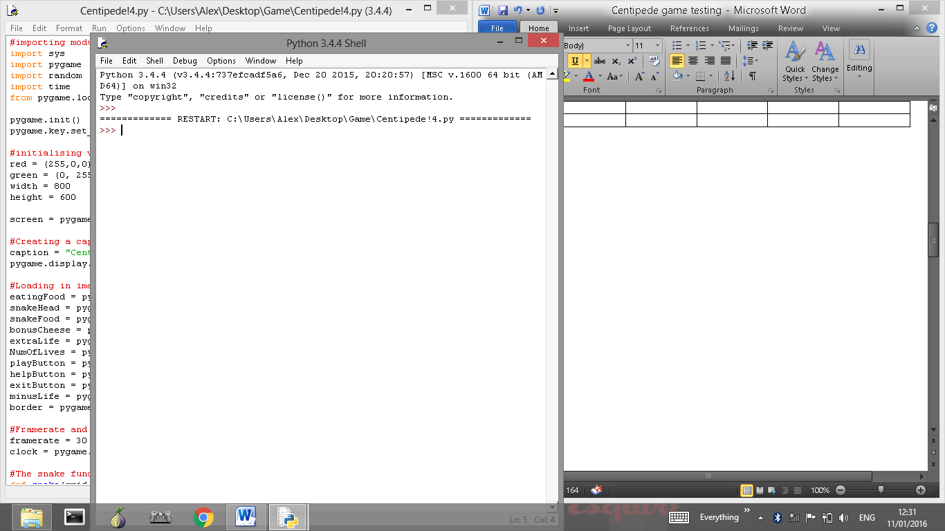

Test 2

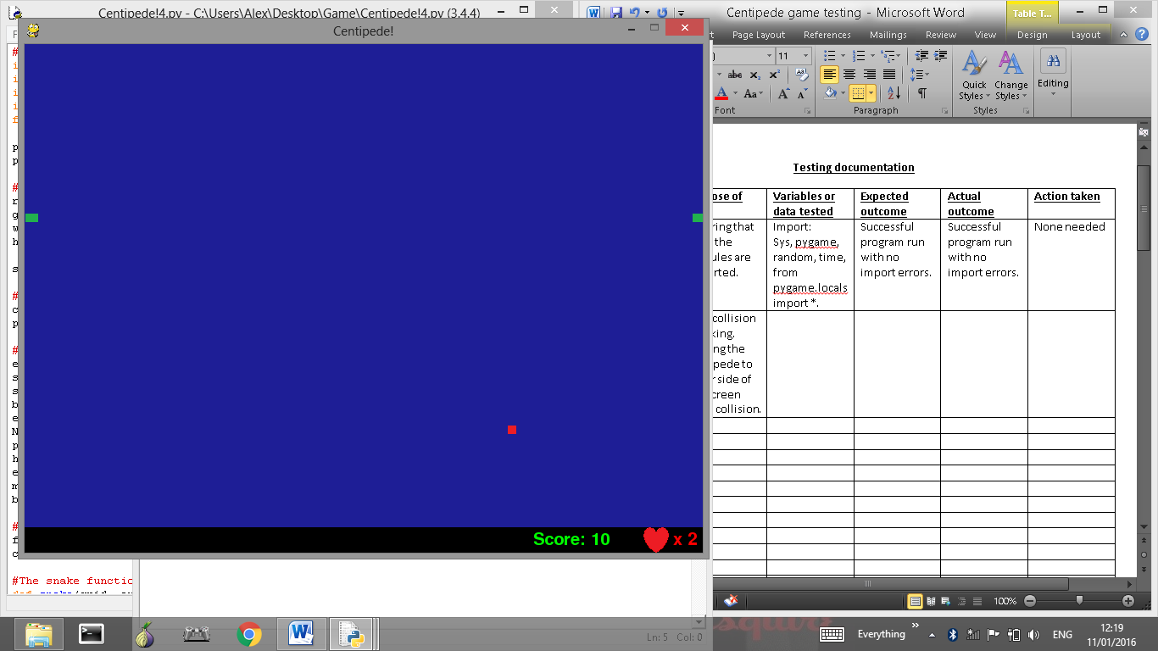

Test 3

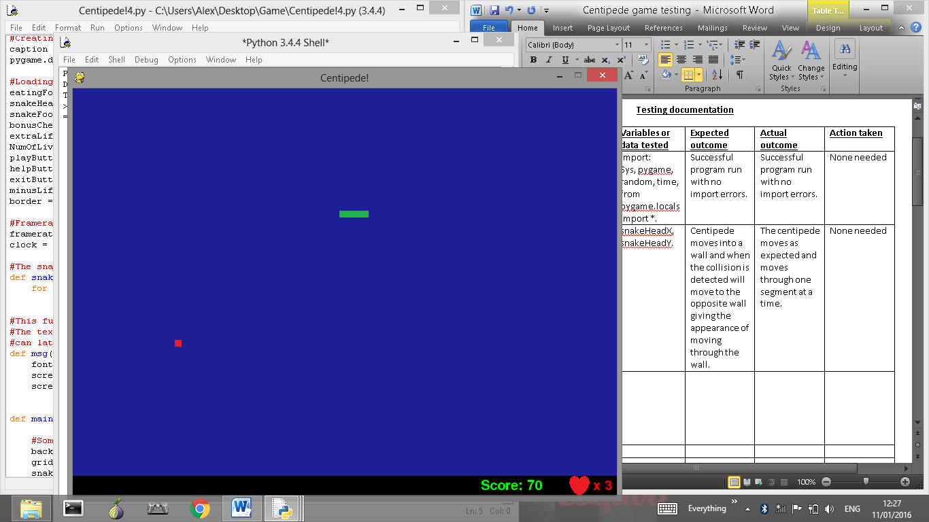

Test 4

No screenshot needed as sound is being tested.

Test 5

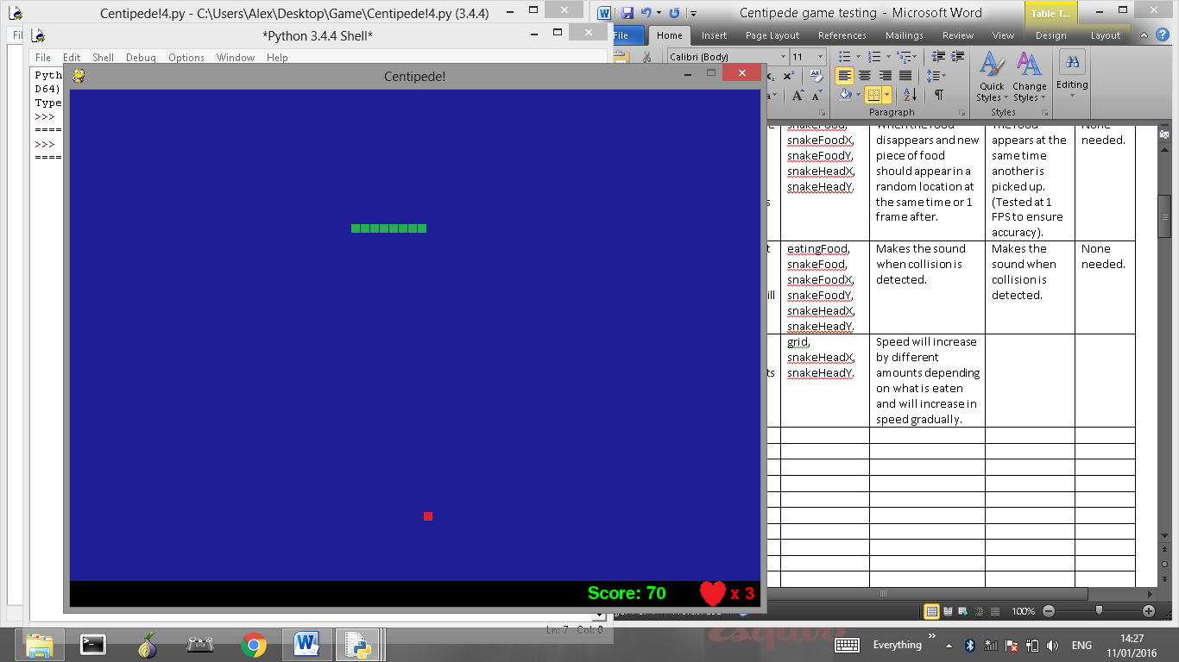

Test 6

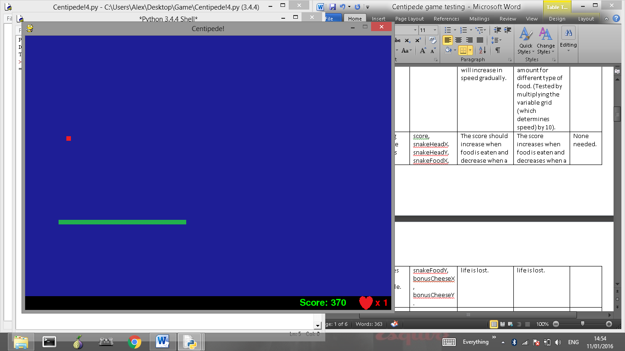

Test 7

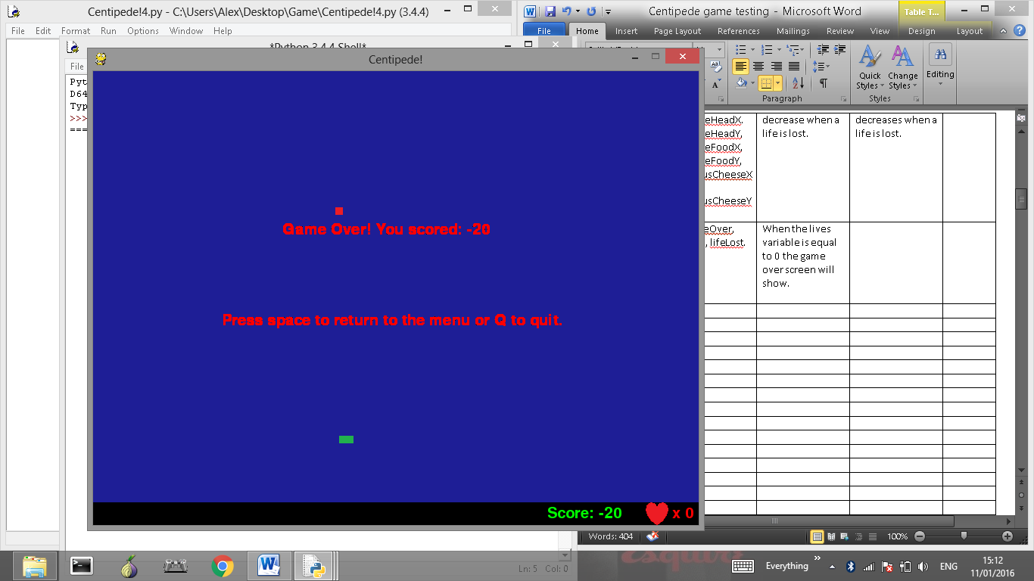

Test 8

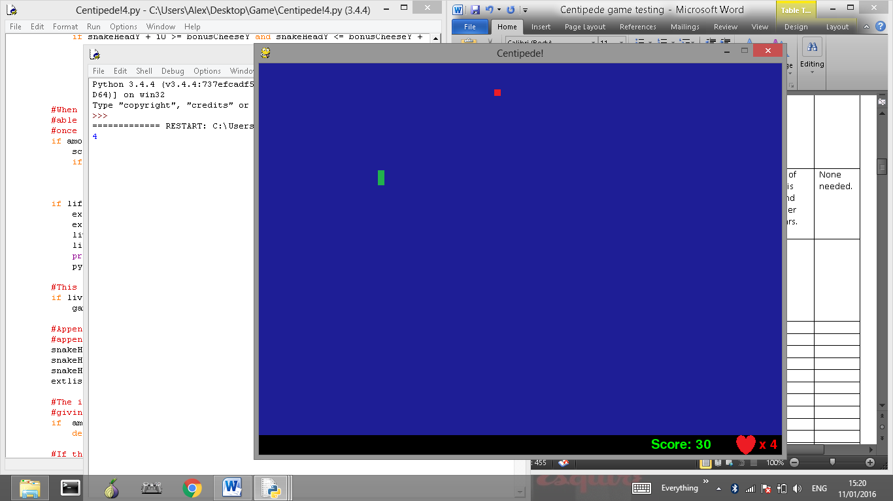

Test 9

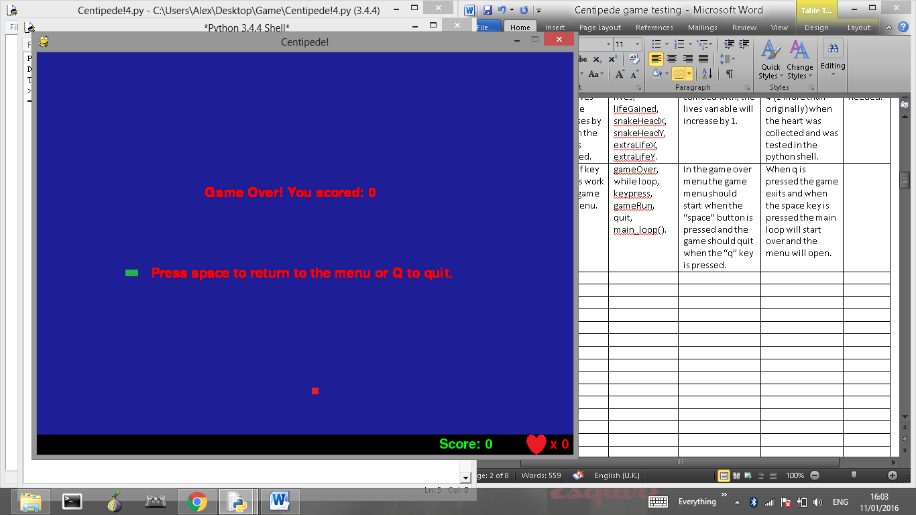

Test 10

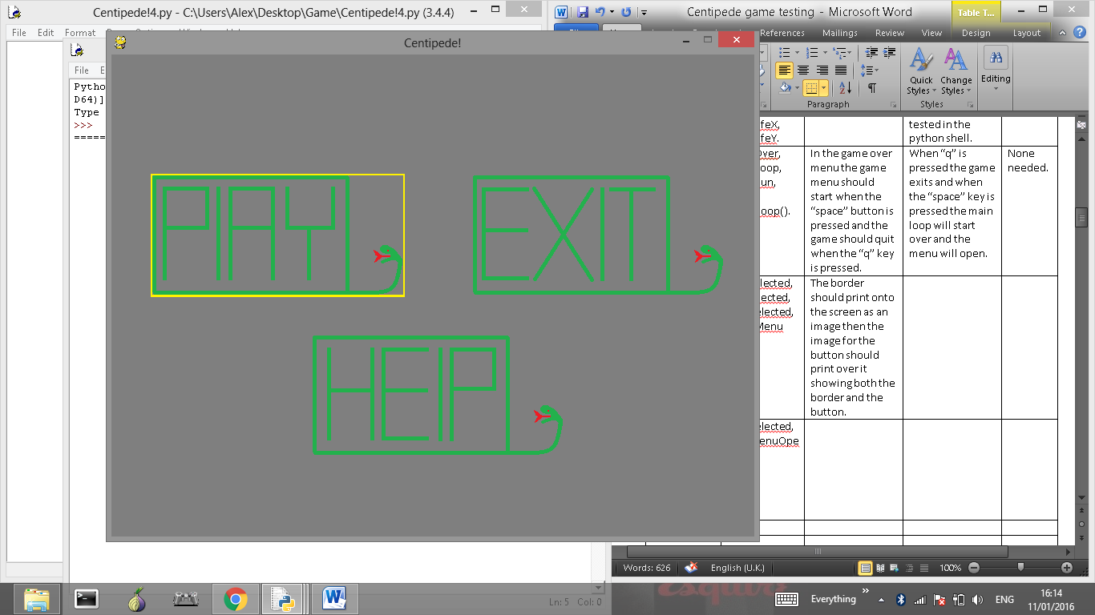

Test 11

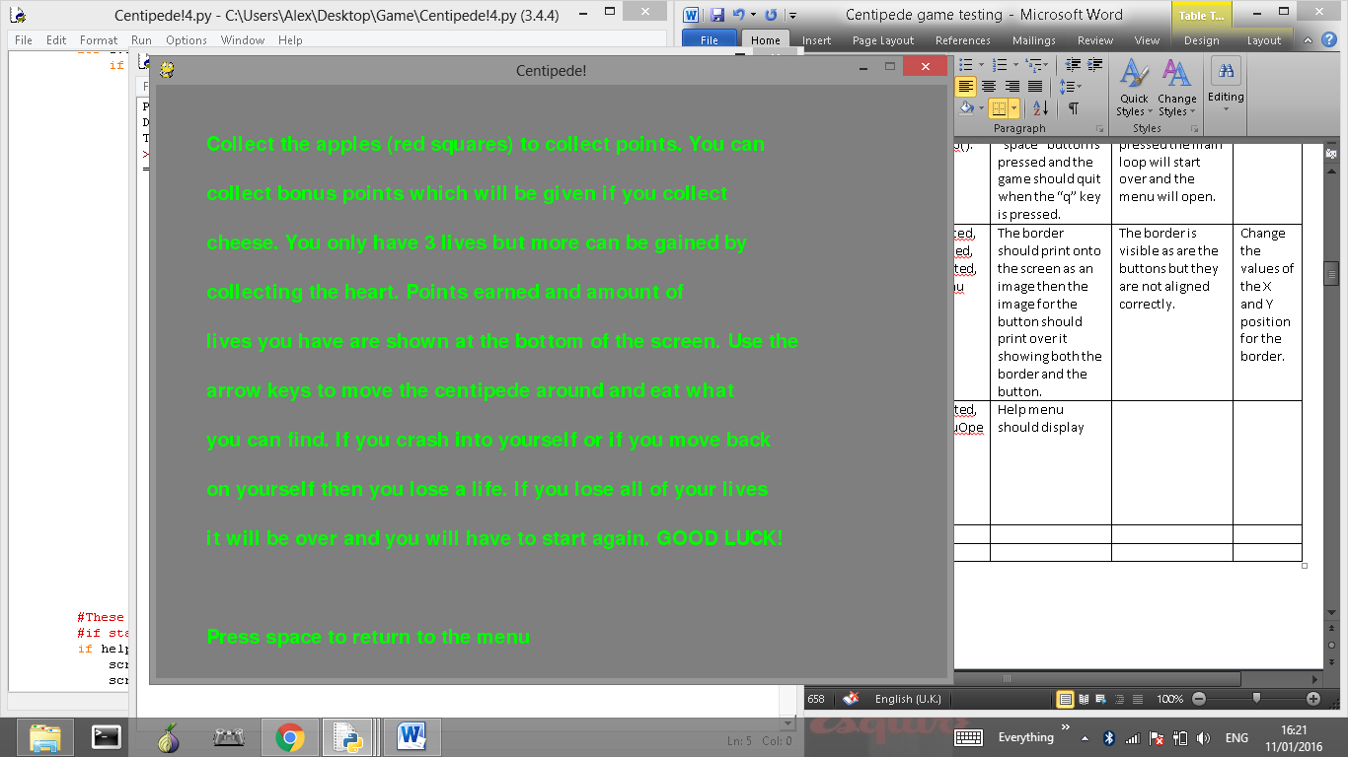

Test 12

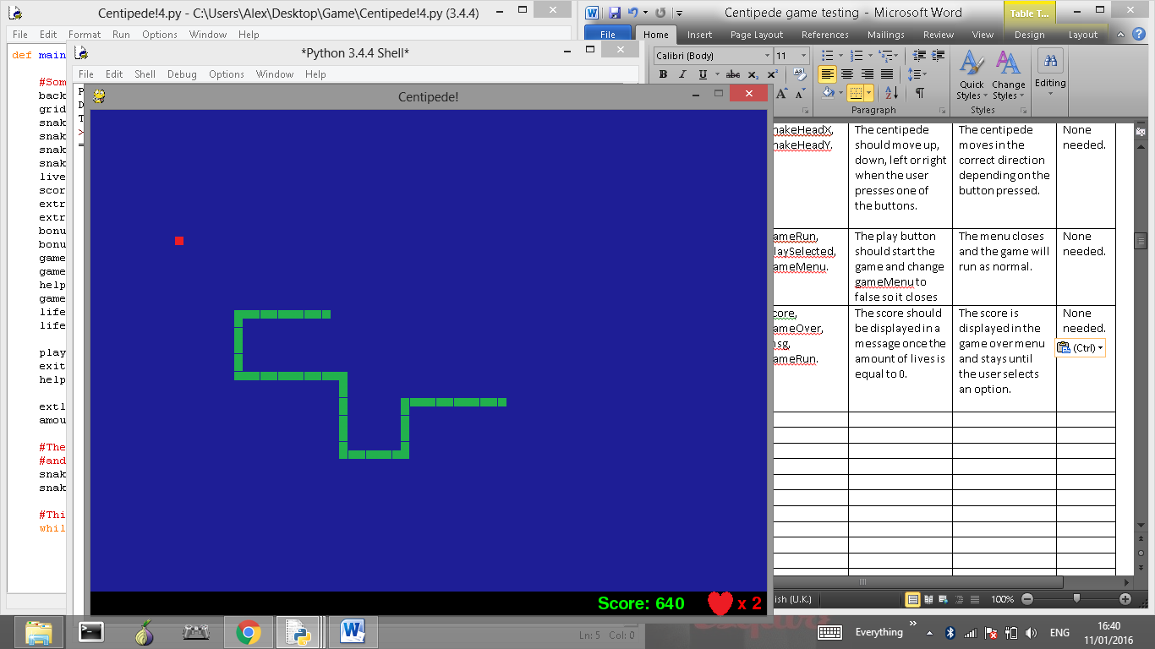

Test 13

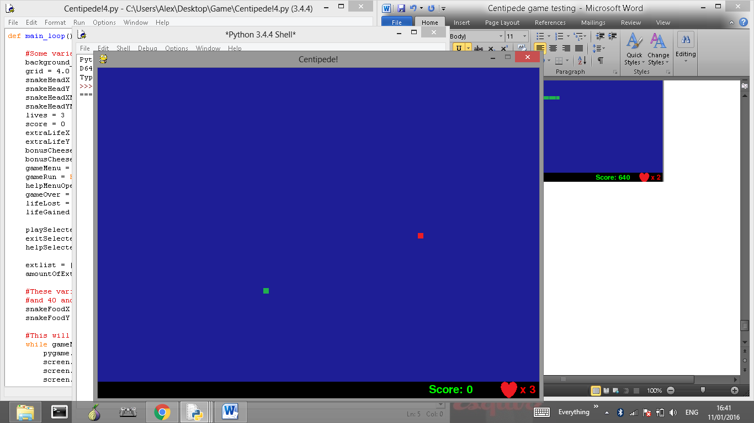

Test 14

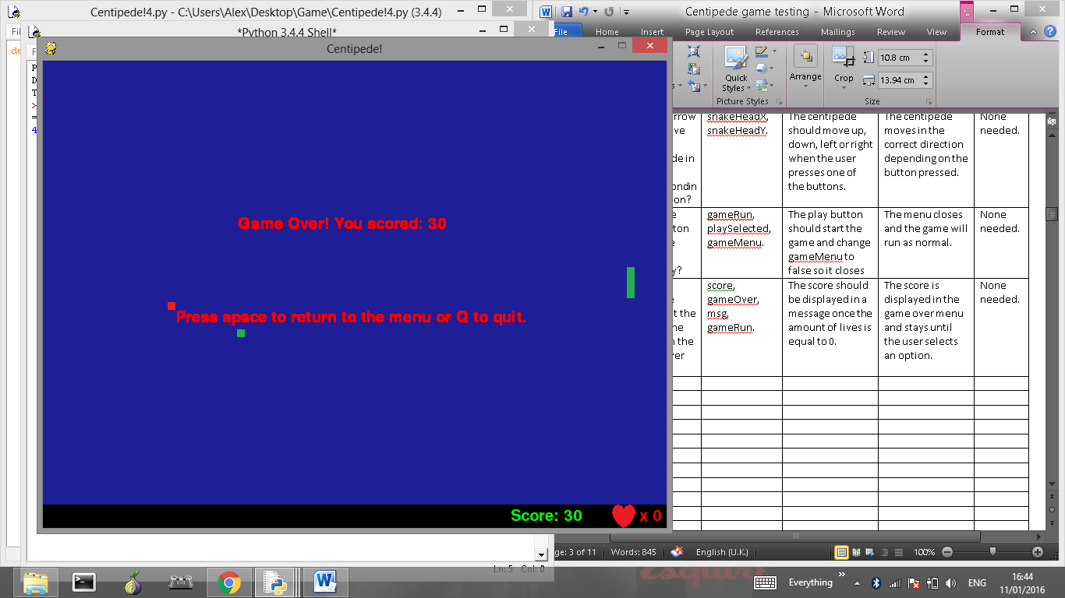

Test 15

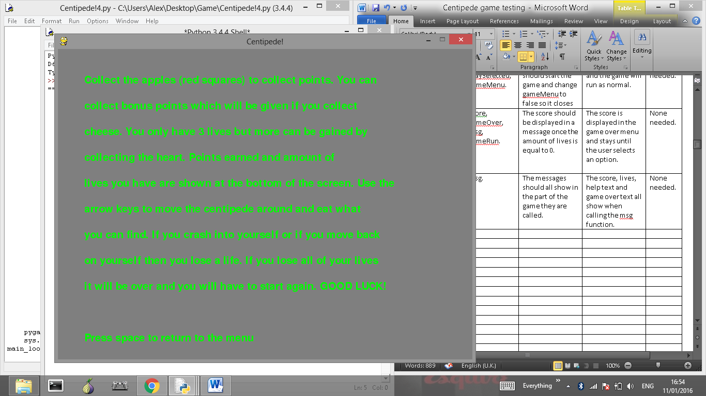

Test 16

No screenshot needed.

Test 17

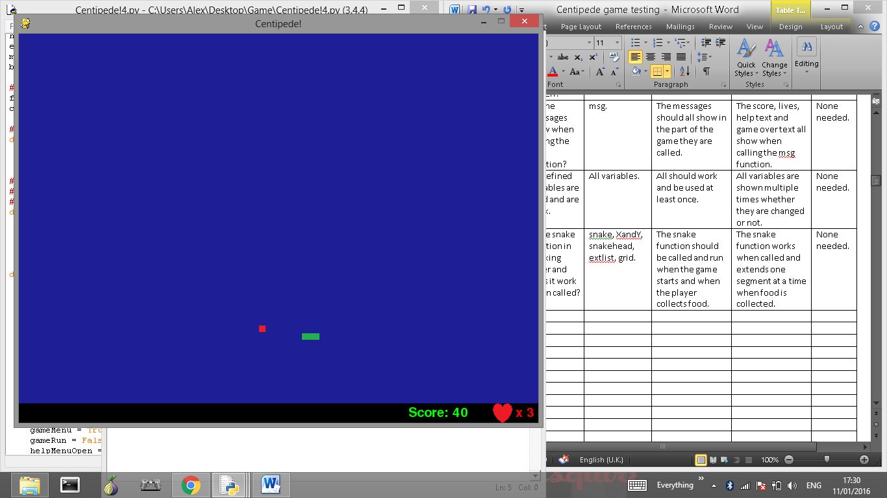

Test 18

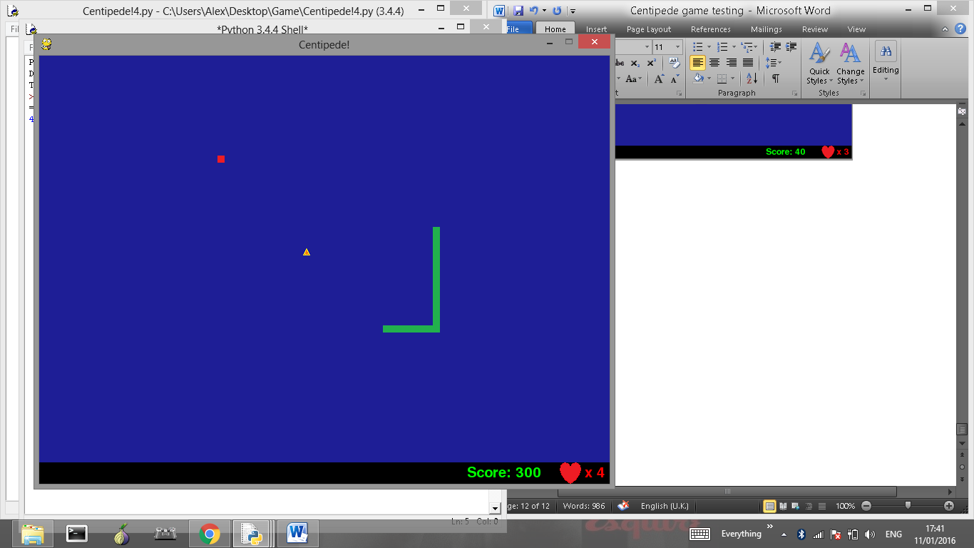

Test 19

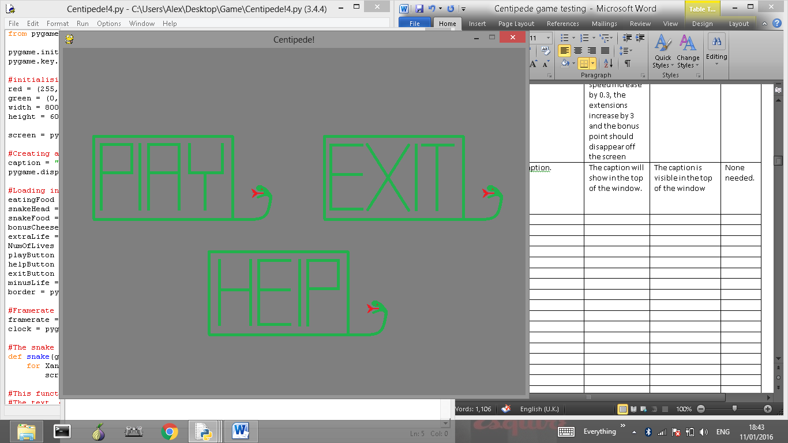

Test 20

No screenshot needed as speed is being tested.

Test 21

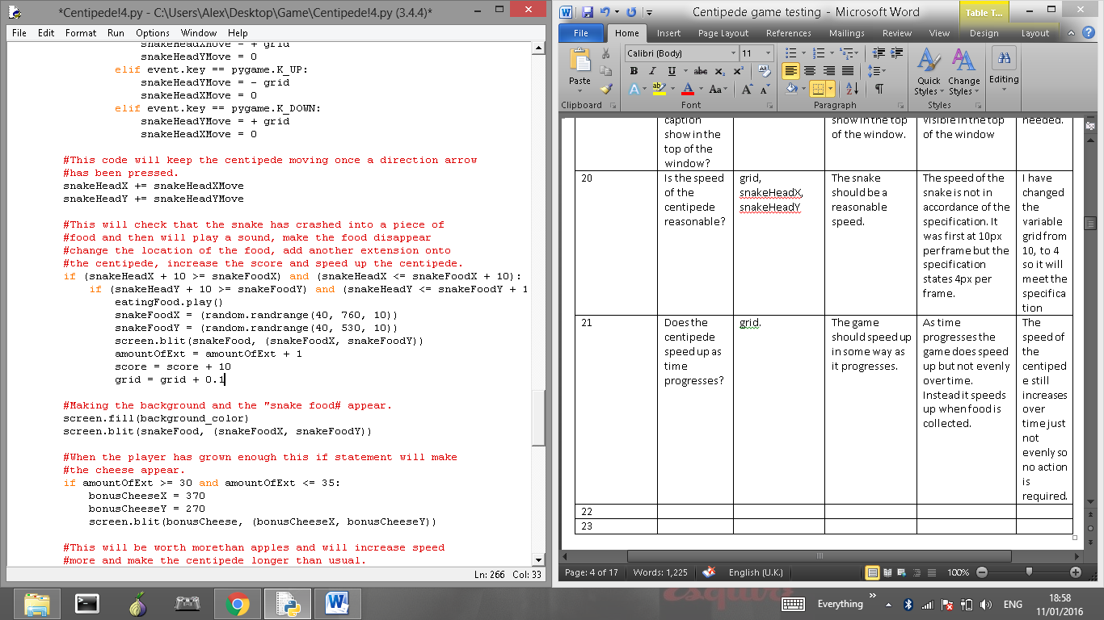

Test 22

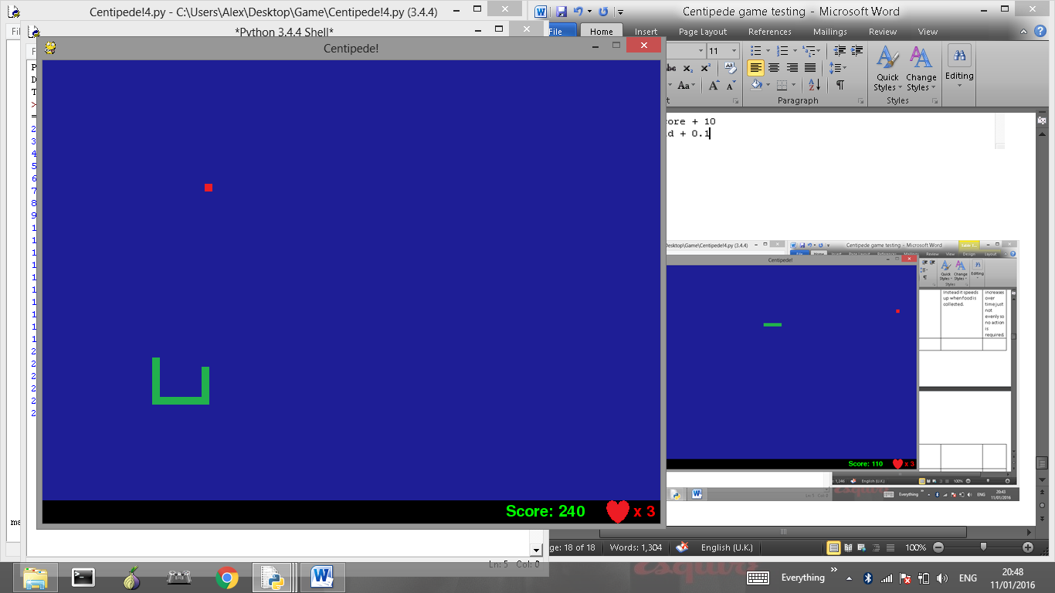

Test 23

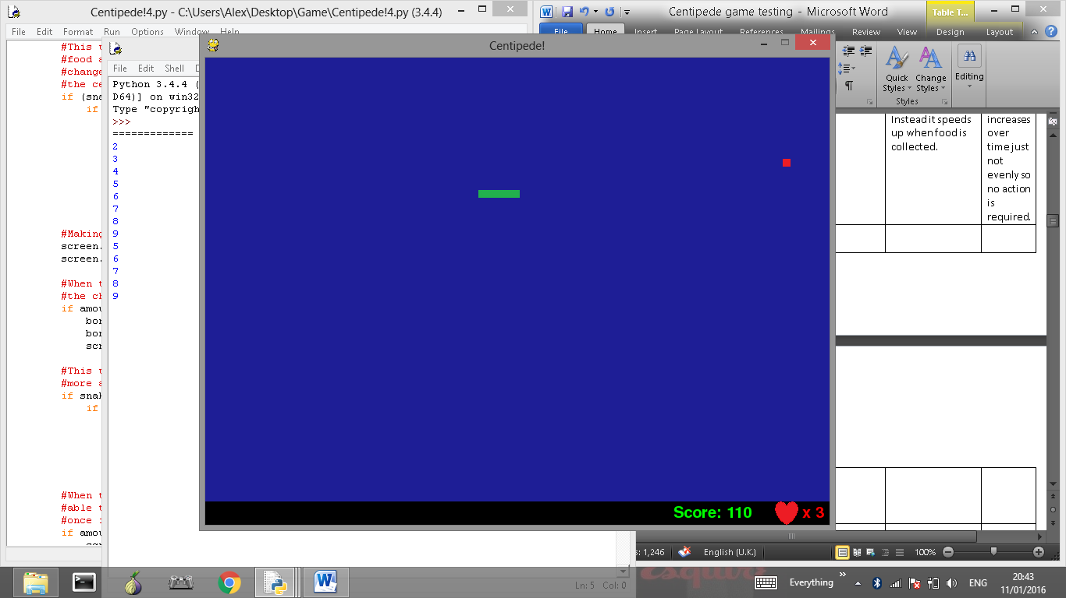

Test 24

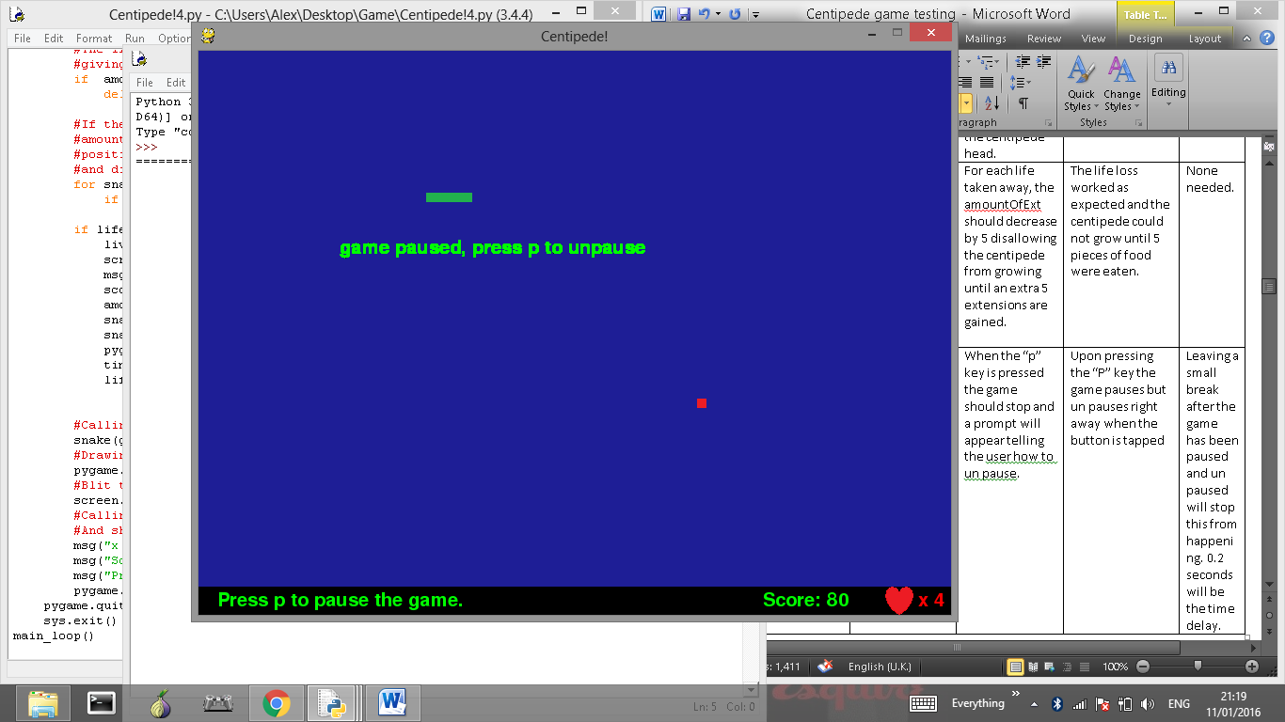

Bugs not fixed.

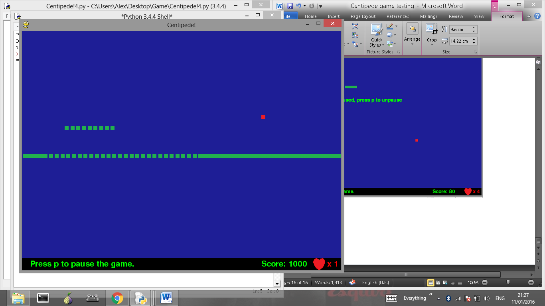

When the centipede dies and appears elsewhere the part of the old centipede will still appear to be moving where it would have eventually disappearing into its own head.

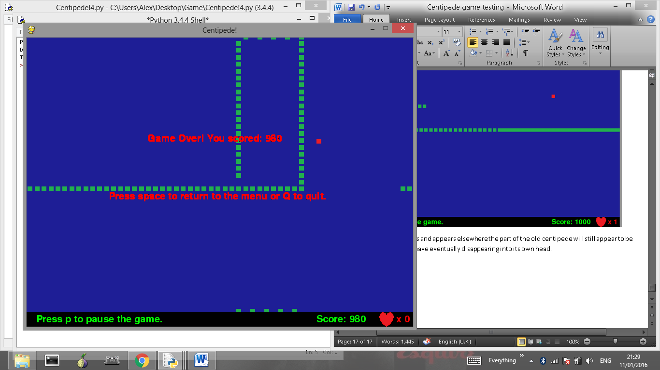

Due to the framerate being so low and the centipede gaining speed, sometimes the segments will appear to disconnect. This could be fixed by increasing the framerate rather than the speed of the centipede.